DURHAM COUNTY SCHOOLS’ ATHLETIC ASSOCIATION

E.S.A.A. NATIONAL CROSS-COUNTRY CHAMPIONSHIPS

Saturday, 14th March 2026 at Sefton Park, Liverpool.

Mr S Hannaford
18 Cannobie Close
Darlington
County Durham
DL3 8RU

Mobile No: 07960-492671
Dear Athlete

You have been selected as a reserve for the ESAA National Championships on Saturday, 14th March 2026, at Sefton Park, Liverpool.
The team and its officials will travel to Liverpool on Friday 13th March and stay overnight, compete on Saturday afternoon and return home on Saturday evening. You will be informed by telephone and post if a place becomes available. Due to lack of space on the coach, reserves do not travel to the event.

Please ensure that you keep in training and remain free from injury so that you may, if the opportunity arises, be able to give your best. We have had to call on a reserve the day before departure in the past, due to illness, so it is never too late.

Please indicate your availability to act as reserve by completing the slip below and returning it to me by Friday 27th February 2026.

Yours sincerely

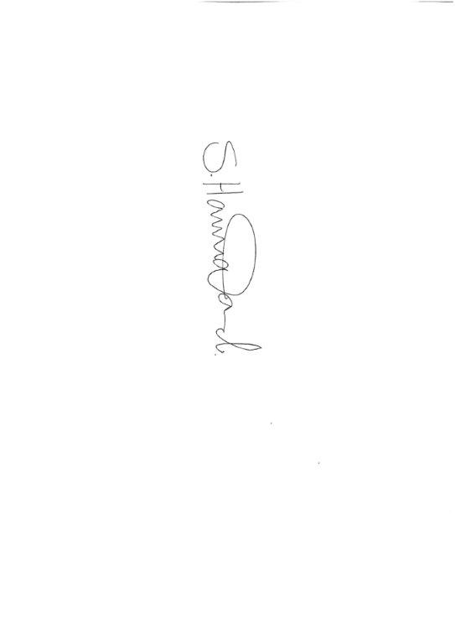
Mr S Hannaford
Team Manager
……………………………………….................................................................…………………………………………………

RESERVE ATHLETE Age group: JB JG IB IG SB SG

NAME OF ATHLETE……………………………………………… DOB …………………………………………….

Contact Phone: __________________ Email__________________________________

I am / am not* willing for my son / daughter to act as a reserve for the ESAA National Championships on English Schools’ Cross-Country Championships on Saturday, 14th March 2026 at Sefton Park, Liverpool.

Signed…………………………………………….. * delete
Parent/Guardian/Carer
Please return to Mr S Hannaford 18 Cannobie Close, Darlington, County Durham DL3 8RU by Friday 27th February 2026.

